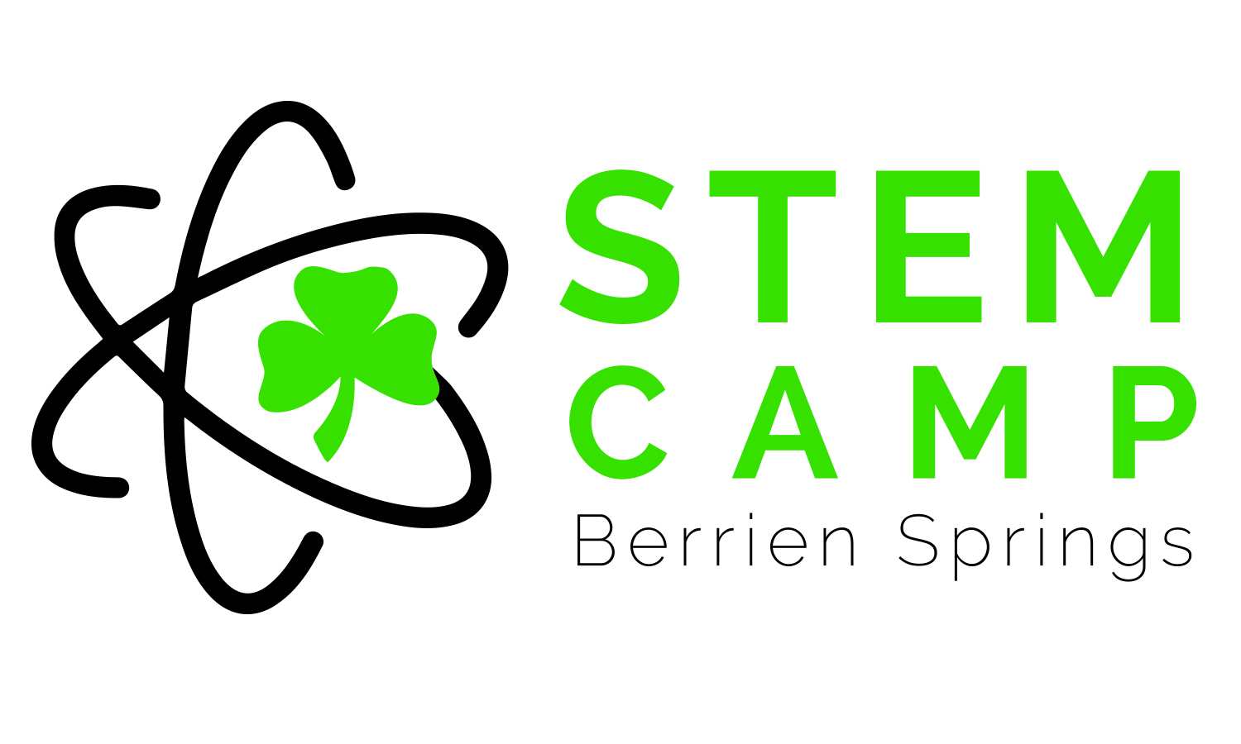

CODING/PROGRAMMING WEBSITES
Grades 3-4
Hello Parents,
Here are the two websites that we used during STEM Camp. The kids really enjoyed playing with the different websites so I hope they continue to explore the programs. It is very simple to navigate through these sites.
- www.code.org
  - Click on the LEARN tab
    - Then click on Hour of Code – You can click on any of the programs offered and tutorial videos if you do not understand how to run the program.
- www.tynker.com
  - SIGN IN – using the provided username and password that I attached to this sheet
    - If you lose their username and password, you can sign up for free.
  - Click on my classroom at the top – STEM Upper Elementary (My picture is on the icon )
    - I have attached different lessons that they can play with. If they complete the lessons and receive a certificate, they can unlock other games for FREE. Otherwise, you can pay for more lessons.
If you have any questions or would like more resources, please feel free to email me, Miss Ornopia, @ gornopia@homeoftheshamrocks.org or Mrs. Haygood @ ehaygood@homeoftheshamrocks.org. We truly appreciate your support. It is always captivating to teach the young minds all about the world of science.

Thank you for being a part of STEM Camp this year,
Miss Ornopia and Miss Elgas

