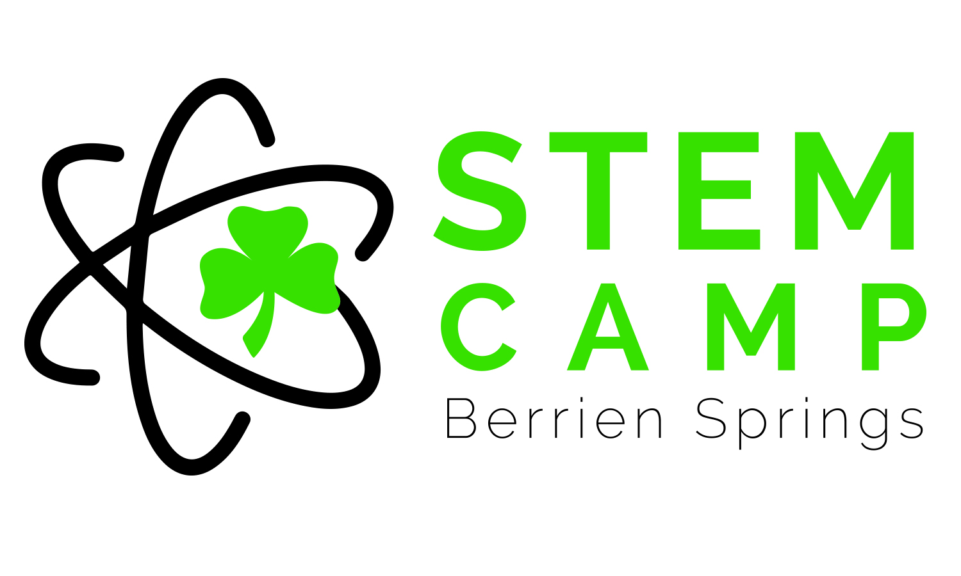
GRADES 3-4
TALL TALES STEM CHALLENGES
Time/Period | Monday | Tuesday | Wednesday | Thursday
8:30-9:00  Introduction/  Warm Up | - Name Continuum  - Fun facts  - Musical Straws  - Scissors  - Straws  - Balloon Speakers  - Balloon | - Two Truths & a Dream  - Sandwich Bag Dart Board  - Sandwich Bags (pint/quart-sized)  - Sharpened pencils  - Water | - Connect the Story  - Pop Rocks Expander  - Pop Rocks  - Balloons  - Funnel  - Soda Bottles (12-16 oz) | - Shoe Pile Mingle  - Soda Can Jump  - Soda Can  - Mug
9:00-9:15  Watch Story | Johnny Appleseed YouTube Video | Pecos Bill YouTube Video | John Henry YouTube Video | Sluefoot Sue YouTube Video
9:15-9:20  Set up activities/  Hand out Materials/  Brainstorm ideas on paper | - Sticks from outside  - Yarn  - Scissors  - Large Tub of water  - Apples | - Plastic grocery bags (4 per person/pair)  - Plastic chair | - Empty cardboard rolls  - Tape, scissors, glue  - Tape measure | - Brown construction paper sheets  - Glue and scissors  - Cardboard pieces  - Weights (pennies & books)
9:20-10:25  Build STEM Challenge | John Chapman Apple Raft Challenge | Pecos Bill Plastic Bag Lasso Challenge | John Henry’s Tube Train Challenge | Sluefoot Sue Log Cabin Challenge (9:20-10:00)  Guest Speaker - ROBOTICS TEAM PRESENTATION (10:00-10:30)  Finish up Sue Log Cabin Challenge (10:30-11:15)
10:25-10:45  Wrap up Challenge | Testing & Challenge Discussion (Lab Sheets) | Testing & Challenge Discussion (Lab Sheets) | Testing & Challenge Discussion (Lab Sheets)
10:45-11:15  Additional STEM Challenge/  Programming/Coding | www.code.org | Building Pool Noodle Structures With Toothpicks (create a city)  www.code.org | www.tynker.org  - Made student usernames and passwords
11:15-11:30 (Clean up) | Discovery Education Video | Time Warp Trio: 2105 | Magic School Bus: Under Construction | Mesopotamia: Nomads to Farmers  Alexander Graham Bell

